Discussion Thread 3: Recording and Computing Variables

Ruchin Patel
BUSI-820-D2
July 7th, 2021

Author Note

Ruchin Patel
I have no known conflict of interest to disclose.
Correspondence concerning this article should be addressed to
Ruchin Patel
Email: rpatel22@liberty.edu
D3.1 Recoding Variables. Why did you recode ‘father’s education’ and ‘mother’s education’? When would you not want to recode normal/scale level variables into two or three categories?
D3.1.a
The reason that ‘father’s education’ and ‘mother’s education’ was recoded there is an issue with the ordering the values in the general format. This is because the coding was wrong where someone who had a higher degree might be coded as having less education than some with some college and no degree. This essentially refers to the variables were not ordered. Once the coding is done the right way it will allow the proper statistical examination (Morgan et al, 2013).
D3.2 Computing Variables. Why did you compute parent’s education?
We computed parents’ education to get full analysis and see if there is data missing and figure out what percentage of education did each parent have. Furthermore, recoding of father’s education and mother’s education is done so that those with no postsecondary education (2s and 3s) have a value of 1, those with some post-secondary will have 2 and those with bachelor’s degree or more will have a value of 3.
D3.3 Evaluating Data. In Output 5.5, do the ‘pleasure scale’ scores differ markedly from the normal distribution? How do you know? Is ‘math courses taken’ normally distributed?
We know that the pleasure scale can vary between 1.00 and 4.00, however the score in the group is 1.50, thus that is ok. Yes the math courses are normally distributed since they ar within range of 1 to 5.
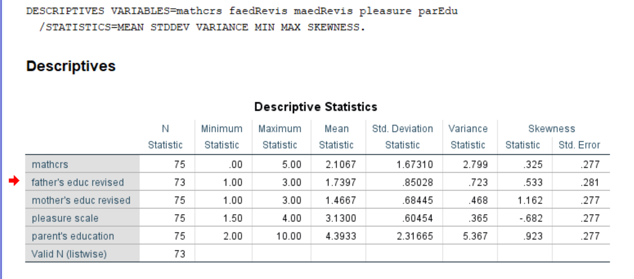

D3.4 Interpreting Statistics. When p < 0.05 what does this signify?
The calculated value or statistical significance is compared to a critical value. In any statistical analysis done usually by a computer a probability value also called a significance value (Morgan et al., 2013). The probability or p is a small, calculated value. As mentioned in Morgan et al. (2013) if a probability is less than a present alpha level usually .05, we can say that the results are statistically significant or that they are significant at the p< 0.05 level. Thus, in this case the null hypothesis is rejected. This is also where we can interpret that there is statistically significant, and it is not likely due to chance but not necessarily important or practical.
D3.5 Choosing Statistics I. What information about variables, levels, and design should you keep in mind in order to choose an appropriate statistic?
First, you have to define the level of measurement of each variable to be included in the analysis. Your variables will be categorical or nominal, ordinal or rank-ordered, interval, or ratio-level. This needs to be done for both your independent and dependent variables. A nominal level variable is a variable where the categories just have names, such as male/female, race, or whether participants are in the control or experimental group. Rank-ordered data is data that is ordered, like a horse race: first, second, third, etc.; the main point is that the distance between first and second and between second and third are different from each other. When the distance between units is the same, you have interval data. Interval-level data have equally spaced units, such as a Likert type scale from 1-7 with 1 equal to strongly disagree and 7 equal to strongly agree. Ratio-level data are similar to interval level data, except that the data have a zero point in it, like age, time, or amounts.
Second, to select the correct statistical analysis, you have to clarify what you want to find out. The research question or hypothesis is typically phrased in terms of finding differences, relationships, or predicting. “Difference-type” questions have interval or ratio-level Y variables, and categorical-level X variables, phrased as, “Are there difference on the variable Y by variable X?” or, “Are there differences on variables Y1, Y2, and Y3 by variables X1 and X2?” The appropriate statistical analyses for these questions are ANOVA and MANOVA, respectively.
For relationship questions with interval, ordinal-level, or ratio-level variables, the correct statistical analysis is correlations. Relationship questions with two categorical variables can be examined with a chi-square test. Typically, linear, ordinal, or multinomial regressions are the appropriate statistical analyses to use when the outcome variables are interval, ordinal, or categorical-level variables, respectively. The independent variables can be interval/ordinal level variables or categorical-level variables.
Third, sample size calculation or power analysis is directly related to the statistical test that is chosen. The sample size calculation is based on the power (typically .80 is desired), the effect size (typically a medium or large effect are selected; contrary to what one might expect, the larger the effect, the smaller a sample is needed), and the alpha (e.g., .05). Given these criteria, the basic rules of thumb are 26 (for a large effect size) and 65 (for a moderate effect size) participants per group for a t-test, chi-square, correlation or linear regression with two predictors.

D3.6 Choosing Statistics II. What statistic would you use if you wanted to see if there was a difference between three ethnic groups on math achievement? Explain why.
We would use the basic statistics. The reason for that would be since the independent variable is nominal. One-way ANOVA (analysis of variance) is the best to use for this specific situation. This statistic is most appropriate because there are three levels of the independent variable, the design is between groups, and the dependent variable is normally distributed. One-way ANOVA repeated measures analysis of variance if you had one categorical independent variable and a normally distributed interval dependent variable that was repeated at least twice for each subject. This is the equivalent of the paired samples t-test but allows for two or more levels of variables.
D3.7 Choosing Statistics III. What statistic would you use if you had one independent variable ‘geographic location’ (North, South, East, West), and one dependent variable ‘satisfaction with living environment’ (Yes, No)? Explain why.

In this case since we have one normally distributed scale dependent variable and four independent variables whole each of then have niminal ordered level, we will use on e of the factorial ANOVA.

